NYS ZONE MAP
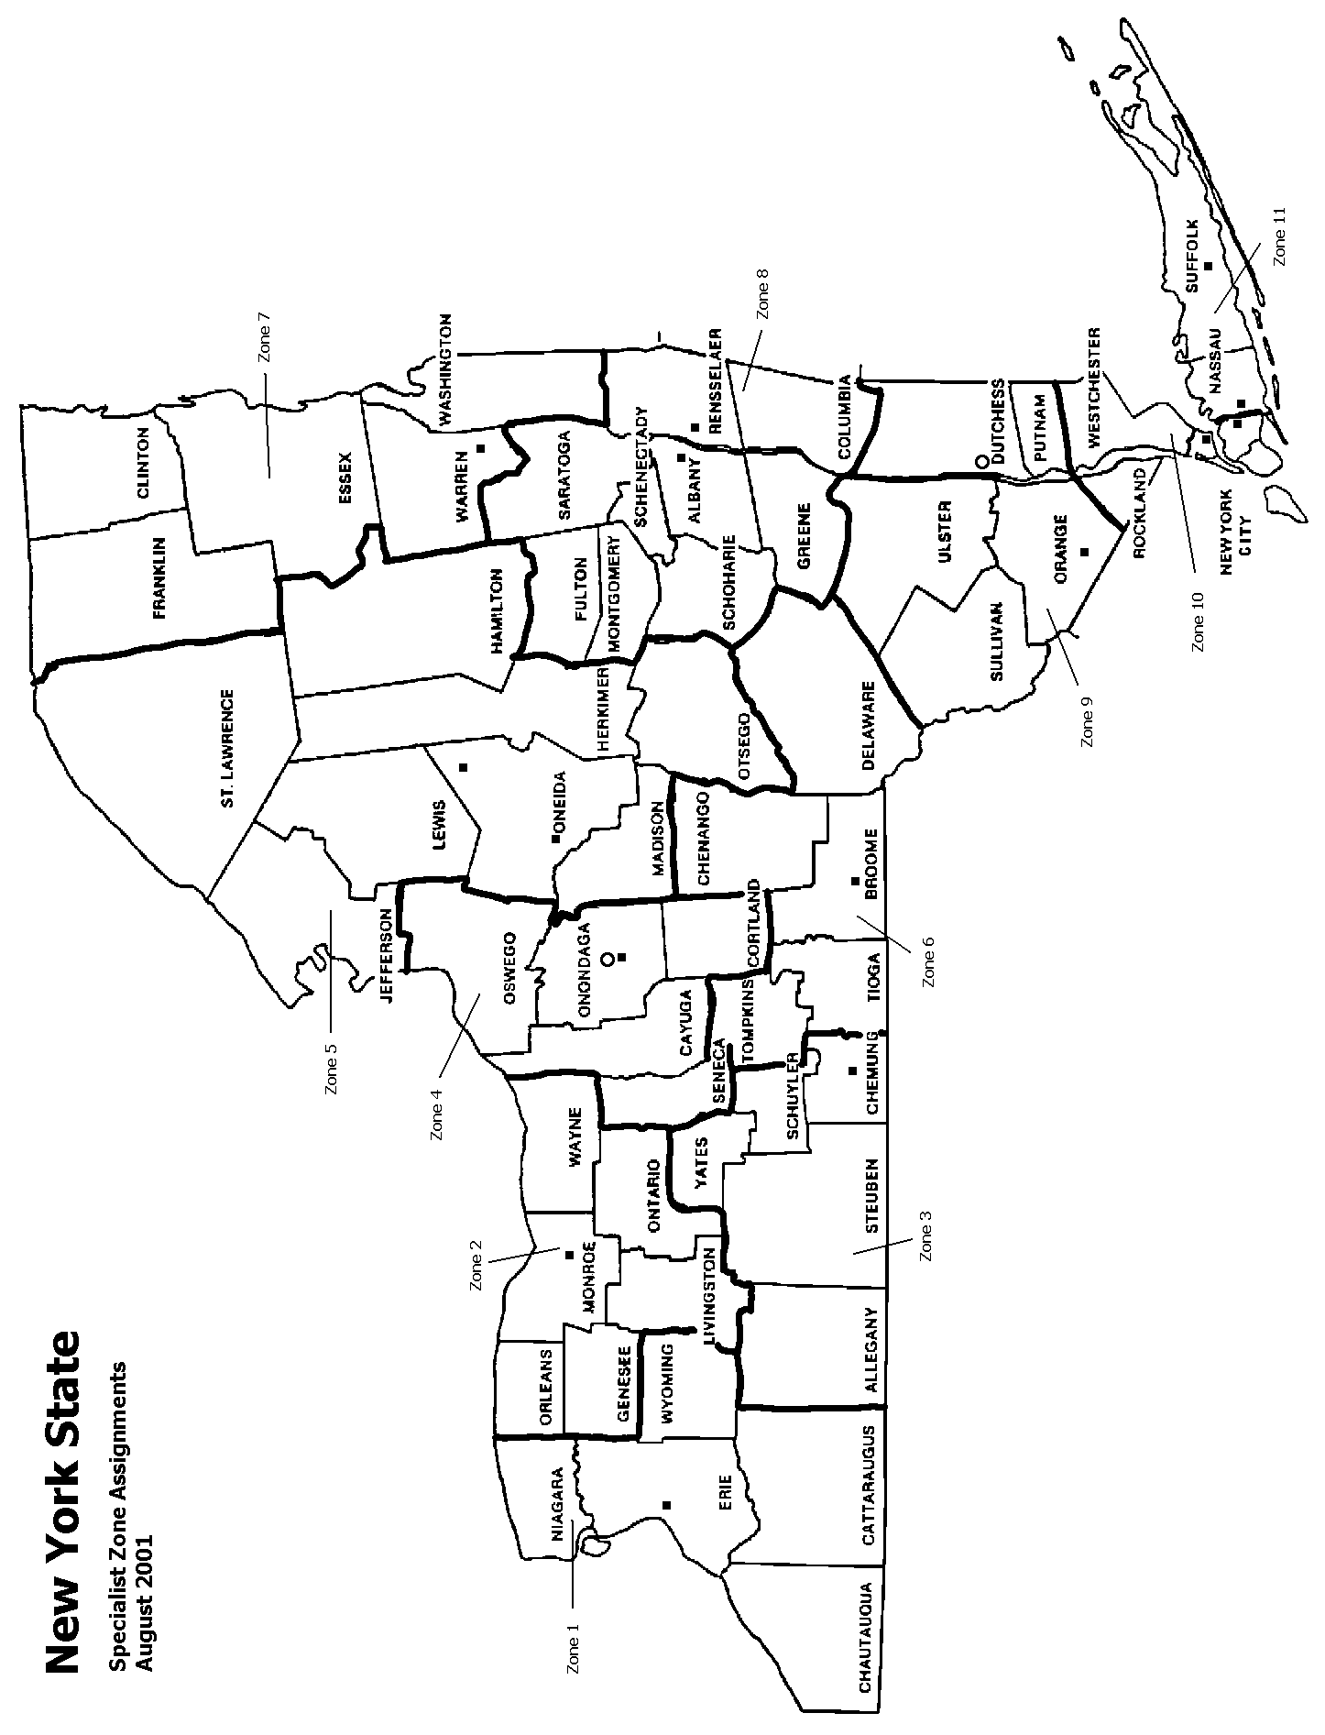

NYS Weights and Measures

Organization Chart

Richard Ball
Commissioner

Steve McGrattan
1st Deputy Commissioner

Vacant
Deputy Commissioner

James Willis
Director

Steve Timar
Assistant Director

Regional Offices
Campus Office
Metrology Laboratory
and Field Services
Main Office (Campus)
Petroleum Quality
and Fuel-NY

Vacant
W&M Specialist II
Vadim Atenzon
PRS II Petroleum
Mandi Monterosso
Secretary I
Joanne Cahalan
KB Spec II
Vacant
KB Spec II
Michael Lejeune
Lab Manager
Jonathan Fox
Metrologist
Jeremy Best
Metrologist
Vacant
Metrologist (NTEP)

See Page 3

Organization Chart
(continued)

Eastern Regional Office
Poughkeepsie
Western Regional Office
Syracuse

William Nebot
W&M Spec II
Michael Smith
W&M Spec II

M. Fleming (Zone 7)
W&M Spec I
C. Chase (Zone 8)
W&M Spec I
John Lee (Zone 9)
W&M Spec I
R. Chowdhury (Zone 10)
W&M Spec I
S. Thomas (Zone 10)
W&M Spec I
Kyle Pierson (Zone 11)
W&M Spec I
J. Esteban (Zone 11)
W&M Spec I

S. Swarner (Zone 1)
W&M Spec I
U. Khan (Zone 2)
W&M Spec I
Vacant (Zone 3)
W&M Spec I
M. Konyak (Zone 4)
W&M Spec I
D. Diegelman (Zone 5)
W&M Spec I
Eric Davis (Zone 6)
W&M Spec I

Special Details |  | Special Details
Highway Weight Enforcement  (WEAP) |  | Large Capacity Scales  (VS)
Liquid Propane Gas  (LPG) |  | NYS 100/10 gallon Prover
Consumer Complaints |  | Fuel NY Program
Training Program |  | Consumer Complaints
 |  | Training Program

A. STATE OFFICES AND PERSONNEL

OFFICES TELEPHONE

CENTRAL 518 - 457-3146
Bureau of Weights and Measures Fax 518 - 457-2552
10B Airline Dr.
Albany, New York 12235 Email agmweigh@agriculture.ny.gov

CAMPUS/METROLOGY LAB
Bureau of Weights and Measures 518 - 457-3452
6 Harriman Campus Rd. Fax 518 - 457-2552
Albany, New York 12206
Email weighlab@agriculture.ny.gov

WESTERN
New York State Fairgrounds 315 - 487-2250
Bureau of Weights & Measures Fax 315 - 487-2408
581 State Fair Blvd., Bldg. 40
Syracuse, New York 13209 Email weighsyr@agriculture.ny.gov

EASTERN
Eleanor Roosevelt State Office Building 845 - 437-5151
Bureau of Weights & Measures Fax 845 - 437-5153
4 Burnett Blvd., Rm. 216
Poughkeepsie, New York 12603 Email weighpou@agriculture.ny.gov

Office Personnel

CENTRAL/CAMPUS OFFICE
James Willis, Director Cell 716-432-9760
Steve Timar, Assistant Director Email james.willis@agriculture.ny.gov
Michael Lejeune, Lab Manager
Jeremy Best, Metrologist
Jonathan Fox, Metrologist
Vacant, Metrologist (NTEP)
Vadim Atenzon, Program Research Spec. II
Mandi Monterosso, Secretary I
Joanne Cahalan, Keyboard Specialist II
Vacant, Keyboard Specialist II

WESTERN OFFICE

Michael Smith, Specialist II Cell 716-572-1741
Email michael.smith@agriculture.ny.gov

EASTERN OFFICE

William Nebot, Specialist II Cell 914-806-0009
Email william.nebot@agriculture.ny.gov

Field Personnel

WESTERN ZONE

Zone 1 Scott Swarner, Specialist I
Cell 716-713-3541
Email scott.swarner@agriculture.ny.gov

Zone 2 Usman Khan, Specialist I
. Cell 585-469-1826
Email usman.khan@agriculture.ny.gov

Zone 3 Vacant, Specialist I
Cell
Email @agriculture.ny.gov

Zone 4 Michael Konyak, Specialist I
Cell 315-879-9500
Email michael.konyak@agriculture.ny.gov

Zone 5 David Diegelman Specialist I
Cell 315-237-4028
Email david.diegelman@agriculture.ny.gov

Zone 6 Eric Davis, Specialist I
. Cell 607-644-6191
Email eric.davis@agriculture.ny.gov

EASTERN ZONE

Zone 7 Matthew Fleming, Specialist I
Cell 315-415-0364
Email matthew.fleming@agriculture.ny.gov

Zone 8 Corbin Chase, Specialist I
Cell 518-817-6230
Email corbin.chase@agriculture.ny.gov

Zone 9 John Lee, Specialist I
Cell 845-416-8598
Email john.lee@agriculture.ny.gov

Zone 10 Ratan Chowdhury, Specialist I
Cell 914-642-3033
Email ratan.chowdhury@agriculture.ny.gov

Zone 10 Stanly Thomas, Specialist I
Cell 718-490-8362
Email stanly.thomas@agriculture.ny.gov

Zone 11 Kyle Pierson, Specialist I
Cell 838-291-6852
Email kyle.pierson@agriculture.ny.gov

Zone 11 Joe Esteban, Specialist I
Cell 516-287-6969
Email jose.esteban@agriculture.ny.gov

Specialist I.D. Numbers

ID No. Last, First (Name)

929 Thomas, Stanly
933 Timar, Steve
944 Mike Smith
945 Joe Esteban
946 Corbin Chase
949 Michael Konyak
951 Matthew Fleming
952 Michael Lejeune
953 Jonathan Fox
954 Scott Swarner
955 William Nebot
957 Usman Khan
959 Jeremy Best
960 David Diegelman
962 Ratan Chowdhury
963 Eric Davis
964 John Lee
965 Kyle Pierson

Special Use ID Numbers (for training, expenses, etc)

947 James Willis

